**Basic VLAN Lab**

When we have more than 1 PC, like in the following topology, switch becomes essential, because one PC has one ethernet port and it needs to be able to communicate with other PCs too. Don’t want the PC’S to communicate with each other, are part of different departments thus need to configure VLAN. We are using a Qemu based switch in our topology. The three PC’s lie in three different VLANs

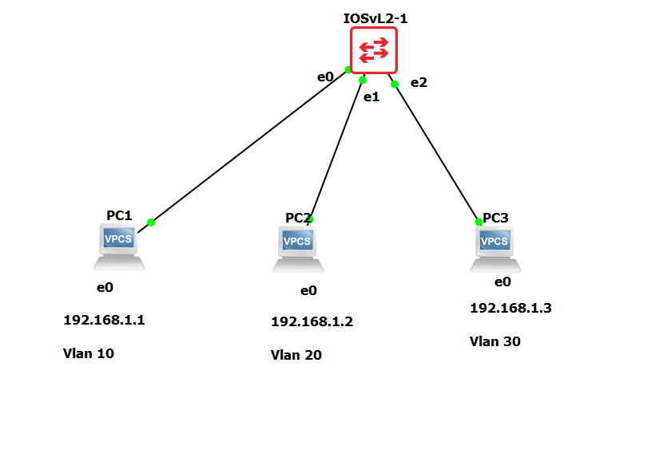

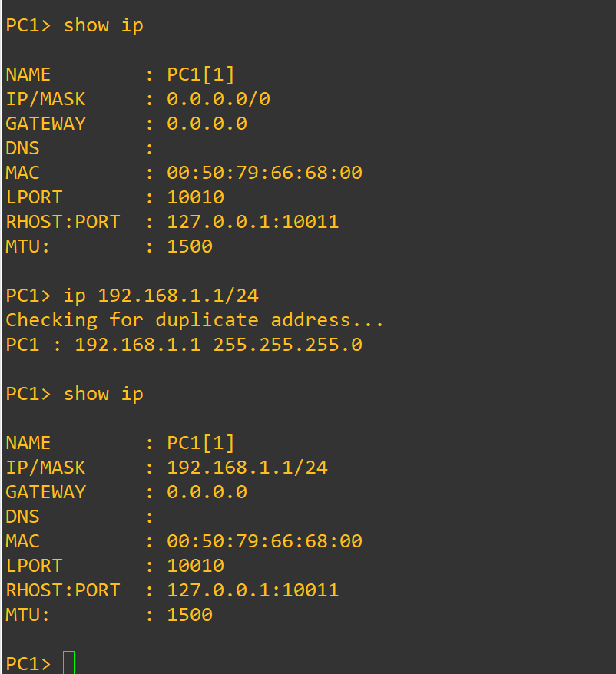

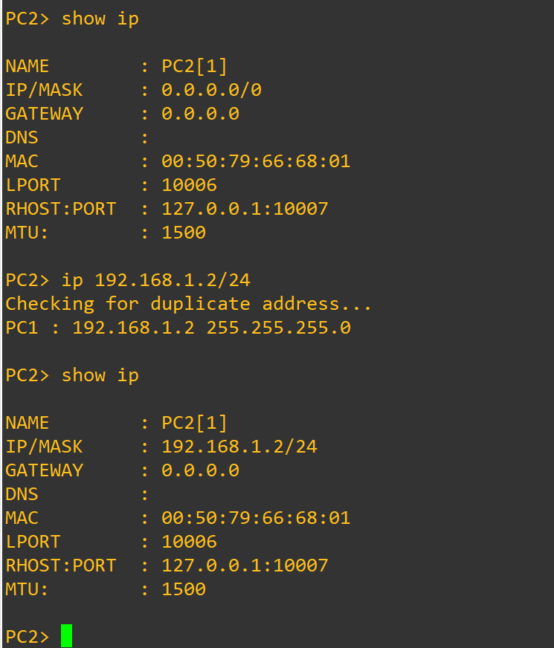

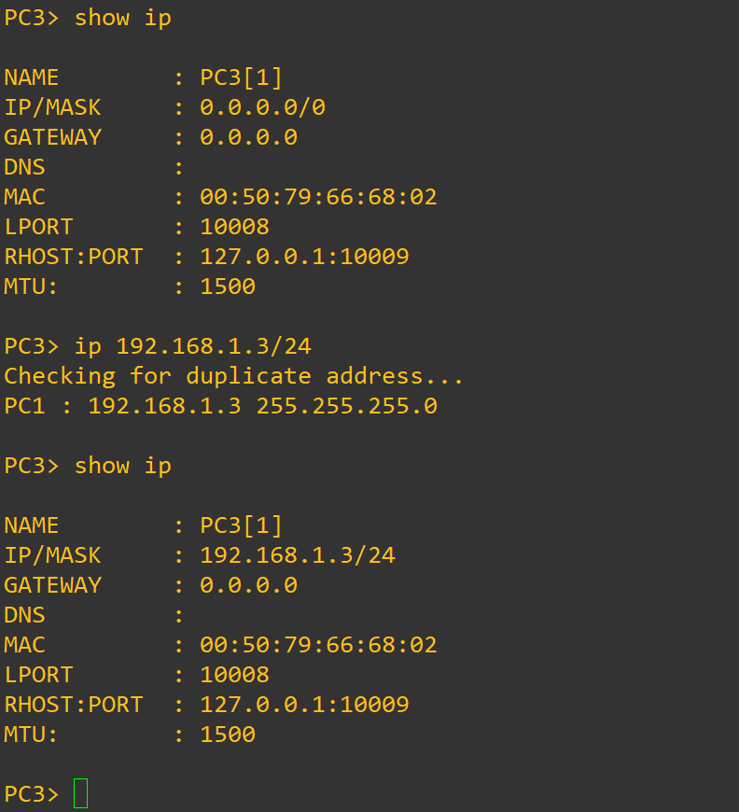

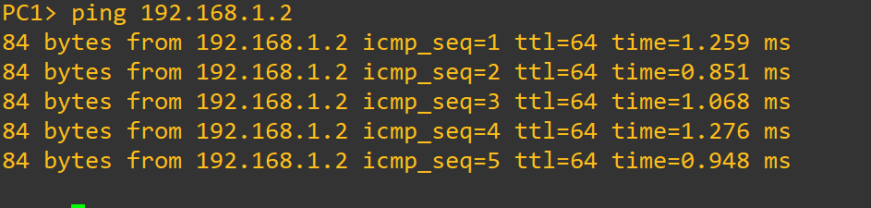

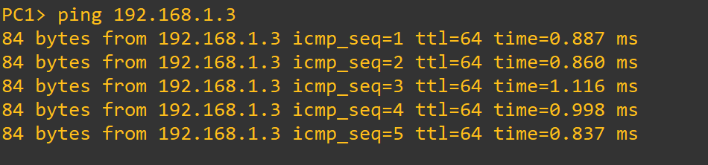

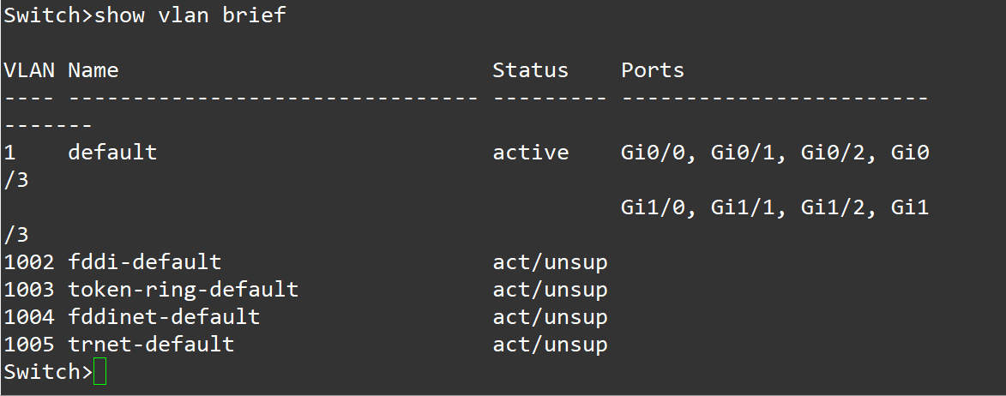

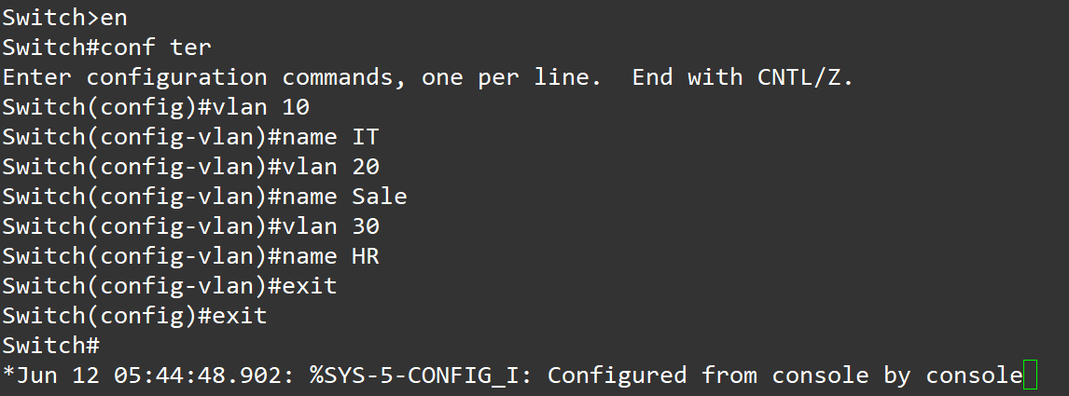

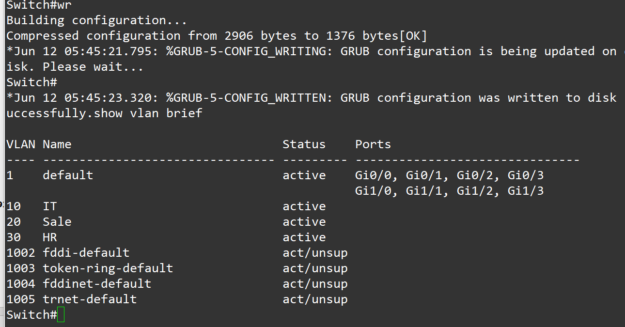

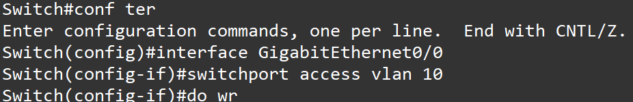



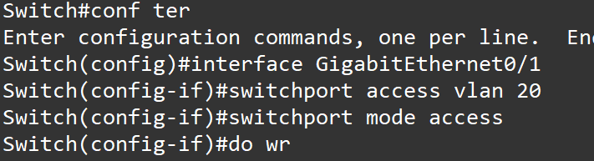

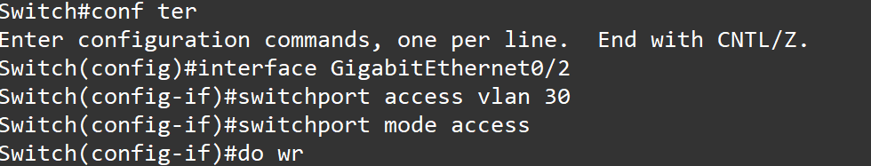

Different VLAN’s only communicate if we configure inter VLAN

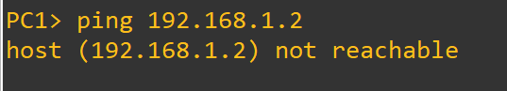

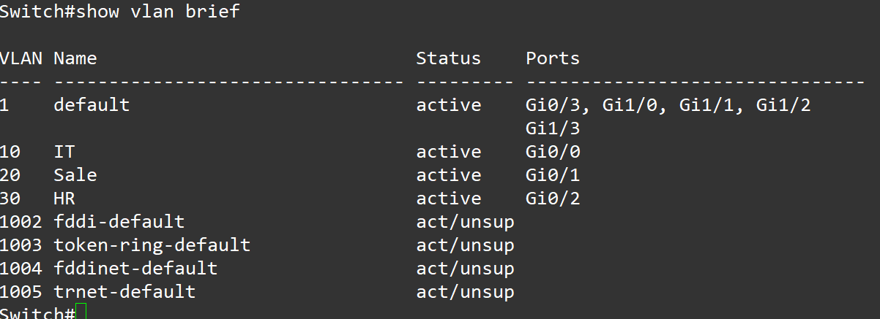

How to configure interVLAN

